Water Quality Assessment of the Kenai River Watershed from 2000 to 2022 [DRAFT]
Benjamin Meyer, Kenai Watershed Forum
2023-11-20
Table of contents

Preface
This document is a report on the project, “Water Quality Assessment of the Kenai River Watershed, 2000 - 2023.” It is an update to historical reports summarising available data to date (McCard 2007; Guerron Orejuela 2016).
This draft report is best accessed as an online interactive document at https://kenai-watershed-forum.github.io/kenai-river-wqx-report-v2/, where it can also be downloaded as an Microsoft Word document. All project files and source code are hosted in a public GitHub repository, also accessible at the above URL.
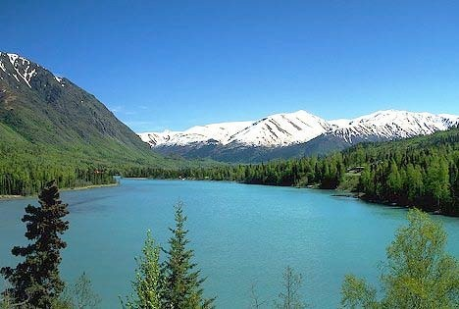
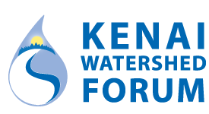

Acknowledgements
This study could not have been completed without the assistance and cooperation of many state agencies including the Alaska Department of Environmental Conservation (ADEC), the Alaska Department of Natural Resources, and the Alaska Department of Fish and Game. The Kenaitze Indian Tribe, Cook Inlet Aquaculture Association, SGS Alaska Laboratory Analytica Laboratories, Kenai Peninsula Trout Unlimited and Taurianen Engineering and Testing also supported this project. Additional cooperation transpired with the United States Forest Service, the United States Fish and Wildlife Service through the Kenai National Wildlife Refuge, the Kenai Peninsula Borough, the City of Soldotna, and the City of Kenai. Finally, many landowners graciously allowed access to the Kenai River and its tributaries from their property.
Thank you to all the staff at the Kenai Watershed Forum that made this project possible. Special thanks to …

Abstract
The Kenai Watershed Forum and several governmental agencies formed a cooperative partnership to collect and analyze water samples from 13 locations along the Kenai River mainstem and from eight of its tributaries every spring and summer from 2000 to 2023. Laboratory analysis was conducted on dissolved metals, total metals, nutrients, hydrocarbons, fecal coliform bacteria, and several other parameters. These results are herein compared to Alaska and federal water quality standards for freshwater aquatic life. [Summarize final results here when available].

Units
Conversions:
- 1 gram = 1000 micrograms
- °F = 9/5(°C) + 32
Unit Abbreviations:
- mg/L = milligrams per liter
- μg/L = micrograms per liter
- CFU/100m = coliform forming units per 100 milliliters
- μS/cm = microsiemens per centimeter
- NTU= nephelometric turbidity unit

Acronyms
Acronyms:
- USEPA (United States Environmental Protection Agency)
- ADEC (Alaska Department of Environmental Conservation)
- DRO (Diesel Range Organics)
- GRO (Gasoline Range Organics)
- RRO (Residual Range Organics)
- BTEX (Benzene, Toluene, Ethylbenzene, and Xylenes)

1. Introduction
This report summarizes water quality data collected between summer 2000 and summer 2022 from 22 sampling locations in the Kenai River mainstem and its tributaries. Local, state, federal, and tribal government entities, as well as several local area non‐profits formed a cooperative partnership so that sampling teams from various agencies were able to collect water samples twice per year, once in the spring and once in the summer, and this effort continues beyond the publication of this report. The locations of the sampling sites are identified with maps, GPS coordinates, and photographs. Trends in the data are highlighted, and the results are compared to the Alaska and federal water quality standards for freshwater aquatic life.
The water quality data focuses on metals, nutrients, hydrocarbons, fecal coliform bacteria, and various field parameters. Arsenic, cadmium, chromium, copper, lead, and zinc are the dissolved metals that have been analyzed, and calcium, iron, and magnesium were reported as total metals. Additionally, the report focuses on the nutrients nitrate and phosphorus. Specifically, the hydrocarbons that were collected and analyzed include diesel range organics, gasoline range organics, residual range organics, benzene, toluene, ethylbenzene, m,p-xylene, and o-xylene. Fecal coliform bacteria, pH, specific conductance, total suspended solids, turbidity, and water temperature are the remaining parameters that have been included in the analysis.
The results are displayed in graphs with associated written analyses and tables. The graphs display the median and variance for each parameter at a specific location, and these graphs are separated depending on whether the data was collected in the spring or in the summer. In some cases, parameters were present in levels that could not be detected by current laboratory analysis, and when this occurred with over 80% of the samples, scatter plots have been displayed omitting the unknown low levels.
[previous reports published in 2007 and 2016]
[Text from 2016 report: A trend analysis was conducted for the following parameters: Lead, Zinc and BTEX; based on the nature of the data, a polynomial line was used because it is the best way to capture and represent the fluctuations in the data.]
Complete data tables can be found in Appendix XXX and XXX, which are organized by parameter and site location, respectively.

2. Study Area
<<<<<<< HEAD

2.1 Description
Located in southcentral Alaska, the Kenai River is part of the Cook Inlet Basin and is linked to the surrounding communities through sport and commercial fishing, tourism, recreation, and the propagation of fish and wildlife (Figure 4.1). Five species of Pacific salmon flourish in the Kenai River Watershed, with sockeye (red) and Chinook (king) salmon as the primary species of interest for harvest in subsistence, sport, commercial, and personal use fisheries (Schoen et al. 2017). The Kenai River his historically produced 80% of the sockeye harvested in Cook Inlet (Dorava and Milner 2000).
Surface runoff, groundwater composition, natural minerals, aquatic plants and animals, and human activities can affect water quality in this area. Potential sources of pollution from humans include gasoline powered boat engines, agriculture, mining, street runoff, and perforated septic tanks (Glass, RL 1999; Reeves et al. 2018; EPA 2011).

2.2 Figures/maps

2.2.1 Online Map of Sample Sites
Access ArcGIS Online map at https://arcg.is/0LXGSf
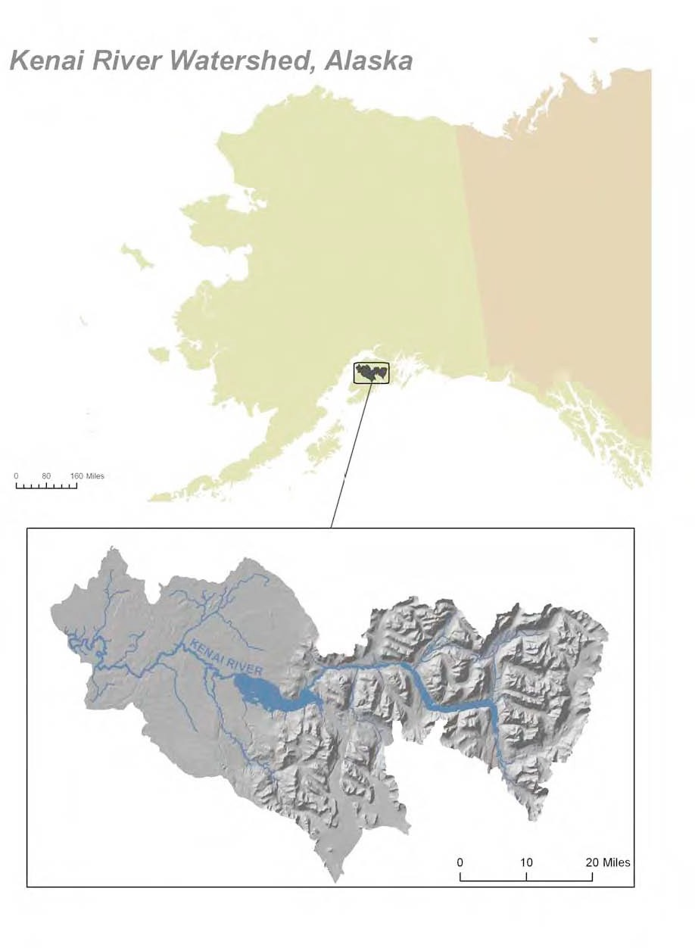
Figure 2.1: Location in Alaska of Kenai River Watershed

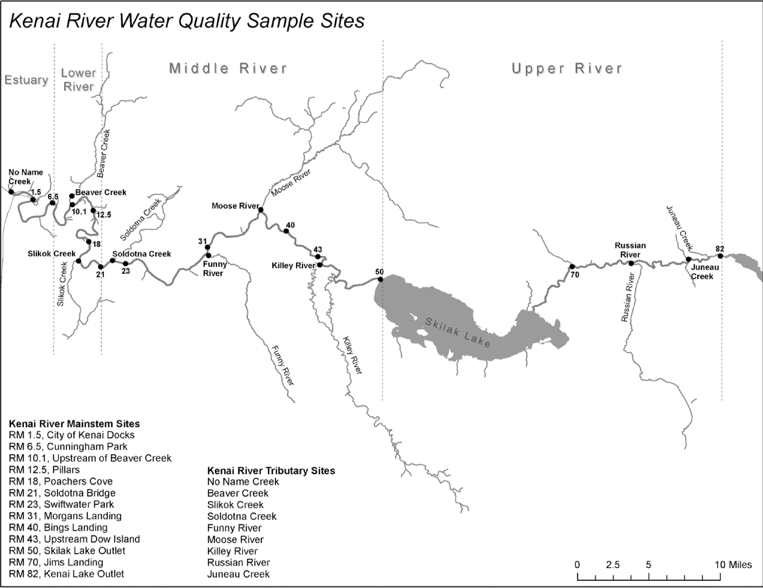
Figure 2.2: Location of water quality sampling sites

2.3 Sampling sites descriptions/photos
Field sampling sites described in Figure 4.2 are introduced below with a photo a coordinates for each location.

2.3.1 Tributary Sites
A brief description of each of the tributary stem field sampling sites, along with coordinates and a photo.

2.3.2 Main Stem Sites
This section will include a brief description of each of the main stem field sampling sites, along with coordinates and a photo.

3.

4. Study Area

4.1 Description
Located in southcentral Alaska, the Kenai River is part of the Cook Inlet Basin and is linked to the surrounding communities through sport and commercial fishing, tourism, recreation, and the propagation of fish and wildlife (Figure 4.1). Five species of Pacific salmon flourish in the Kenai River Watershed, with sockeye (red) and Chinook (king) salmon as the primary species of interest for harvest in subsistence, sport, commercial, and personal use fisheries (Schoen et al. 2017). The Kenai River his historically produced 80% of the sockeye harvested in Cook Inlet (Dorava and Milner 2000).
Surface runoff, groundwater composition, natural minerals, aquatic plants and animals, and human activities can affect water quality in this area. Potential sources of pollution from humans include gasoline powered boat engines, agriculture, mining, street runoff, and perforated septic tanks (Glass, RL 1999; Reeves et al. 2018; EPA 2011).

4.2 Figures/maps

4.2.1 Online Map of Sample Sites
Access ArcGIS Online map at https://arcg.is/0LXGSf
Figure 4.1: Location in Alaska of Kenai River Watershed

Figure 4.2: Location of water quality sampling sites

4.3 Sampling sites descriptions/photos
Field sampling sites described in Figure 4.2 are introduced below with a photo a coordinates for each location.

4.3.1 Tributary Sites
A brief description of each of the tributary stem field sampling sites, along with coordinates and a photo.

4.3.2 Main Stem Sites
This section will include a brief description of each of the main stem field sampling sites, along with coordinates and a photo.

cb4283d25c8f6f21c969c7895136d6d68bddc50e

5. Methods
We collected water samples at 13 locations along the Kenai River mainstem and from eight tributaries near their confluence points (see Figure 4.2). These locations were selected by a technical working group in 1997 to represent diverse regions through the Kenai River watershed’s ambient water quality conditions. Sampling occurred in the spring and the summer each year beginning in summer 2000.
After a half‐day training session, staff from governmental and non‐governmental agencies dispersed between 7:00 AM - 9:00 AM to sampling locations in teams of two or more to collect samples. All samples were collected on the same day, and the timing of the sampling coincided with an outgoing tide, near low tide, to reduce the potential of collecting saline water from Cook Inlet (see Appendix X for timing). Typically, the individual collecting the sample waded into the water until the water level was around two feet deep, and the sample was collected while facing upstream. If the individual collected the sample using a boat, the samples were collected from the bow while the boat faced upstream. The bottles were placed approximately one foot below the surface to collect the water samples and then preserved for transportation to the laboratory. Beginning in spring 2002, two duplicate samples were collected for quality control. These procedures follow the protocols established in a Quality Assurance Project Plan (QAPP) that was originally approved by the ADEC in 2001 and later revised and approved by ADEC again in 2013, 2019, 2020. The QAPP was also reviewed and approved by the Region 10 Environmental Protection Agency office in 2023 [pending as of r Sys.Date()]. The QAPP is available from Kenai Watershed Forum [pending as of r Sys.Date()].
We used the R programming language in Posit software for all analyses, and generated this report using Quarto publishing software. The report is available both as a downloadable PDF and as an online report at [WEB ADDRESS].
In instances where data was reported as not detected the half of the MDL or MRL [ACRONYMS] was used to estimate the values and run the analysis. The MRL was used because during the early years of the project, the lab only provided this information and not the MDL.

6. Data QA/QC

7. Water Quality Parameters Results

7.1 Interpreting Box Plots
Each of the following graphs display the sampling results for a specific parameter, such as arsenic. Within these graphs, a box and extending lines represent the results reported at each sampling site. A horizontal line within the box corresponds to the median of the data. The box contains 50% of the data and the vertical lines display the minimum and maximum values. Any data points that fall outside of the acceptable range are outliers and are portrayed as small circles (Figure 7.1).
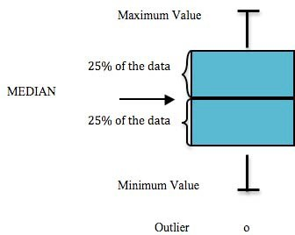
Figure 7.1: Components of a box plot

8. Regulatory Limits
We calculated regulatory limits based on freshwater quality standards listed from state and federal regulatory agencies.
https://dec.alaska.gov/water/water-quality/standards/
##Hardness
Some regulatory values are hardness-dependent, and hardness varies by site, by season, and with hydrologic conditions. We calculated hardness according to the following formula:
Hardness = 2.497(Total Calcium in mg/L) + 4.119(Total Magnesium in mg/L)
For sampling events with duplicate samples, we calculated average hardness
── Attaching core tidyverse packages ──────────────────────── tidyverse 2.0.0 ──
✔ dplyr 1.1.3 ✔ readr 2.1.4
✔ forcats 1.0.0 ✔ stringr 1.5.1
✔ ggplot2 3.4.4 ✔ tibble 3.2.1
✔ lubridate 1.9.3 ✔ tidyr 1.3.0
✔ purrr 1.0.2
── Conflicts ────────────────────────────────────────── tidyverse_conflicts() ──
✖ dplyr::filter() masks stats::filter()
✖ dplyr::lag() masks stats::lag()
ℹ Use the conflicted package (<http://conflicted.r-lib.org/>) to force all conflicts to become errors
`summarise()` has grouped output by 'activity_identifier', 'activity_start_date'. You can override using the `.groups` argument.

9. Arsenic
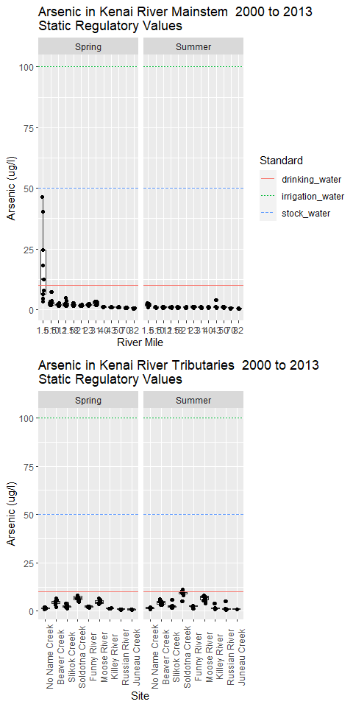

From 2016 report:
Natural sources of arsenic in the Cook Inlet Basin include volcanic ash, glaciation, and mineral deposits. Only a minimal contribution of arsenic results from human activities like wood preservation (Glass and Frenzel, 2001). Arsenic is naturally present as a compound in rocks within the Kenai River Watershed, and as a dissolved metal, it can be acutely or chronically toxic to fish (Glass, 1999). The Alaska Department of Environmental Conservation (ADEC) and the United States Environmental Protection Agency (USEPA) have set the standard at 150 micrograms per liter (µg/L) for freshwater aquatic life chronically exposed to arsenic and 10 micrograms per liter (µg/L) for drinking water (Appendix X) (USEPA, 2014; ADEC, 2008).
None of the samples exceeded the Alaska or federal standard for freshwater aquatic life at any sampling location in spring or summer. The highest level detected in the mainstem was 46.5 µg/L at Mile 1.5 in May 2007, and arsenic was not detected on many occasions below the method detection limit (MDL) of 0.25 µg/L (Table 6). In the Kenai River mainstem, Mile 1.5 had the highest median level in the spring event and summer monitoring event, followed by Mile 6.5 in the spring event and Mile 23 during the summer monitoring event (figures X & X). In the mainstem, higher arsenic levels occurred in the spring samples, while the tributaries levels were higher during the summer with more detected levels between the years 2007-2014 than any of the previous years. (Tables X & X)
The highest concentration on the mainstem occurred at Mile 1.5 where arsenic was detected on every sampling event after 2005, while arsenic was detected on all sampling dates at Beaver Creek, Soldotna Creek, and Moose River. The concentrations of arsenic ranged from a high of 12.8 µg/L in Soldotna Creek in summer 2014 to below the MDL of 0.25 µg/L in many locations. Of the tributaries, Soldotna Creek had the highest median level, followed by Moose River and then Beaver Creek in summer and Soldotna, Beaver and Moose in spring. No Name Creek had the fewest incidences of arsenic detection of all the tributaries. (Tables X & X)
When comparing the arsenic levels to the Alaska Department of Environmental Conservation standards for drinking water, the main stem at Mile 1.5 is the only station that presents multiple exceedances. All exceedances took place during the spring sampling events. (Tables X & X)
Concentrations of arsenic are generally lower in surface streams than in groundwater, which is typically the source of drinking water (Glass and Frenzel, 2001). The USEPA set the criterion for arsenic in drinking water at 10 µg/L because arsenic has been linked to cancer, skin damage, and circulatory problems (USEPA, 2003). Although the levels of arsenic reported in this study do not exceed the national criterion for the health of an aquatic community in freshwater, groundwater may contain concentrations that are hazardous to human health, and all sources of drinking water should be tested for arsenic.

10. Cadmium
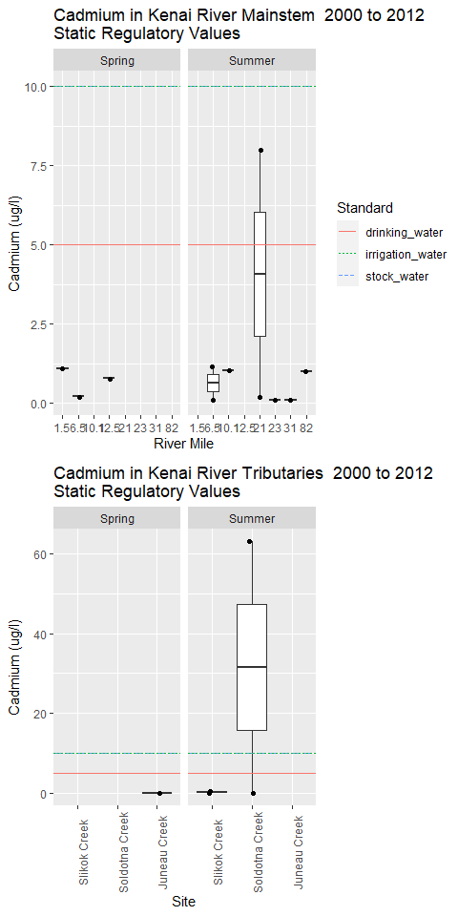

11. Chromium
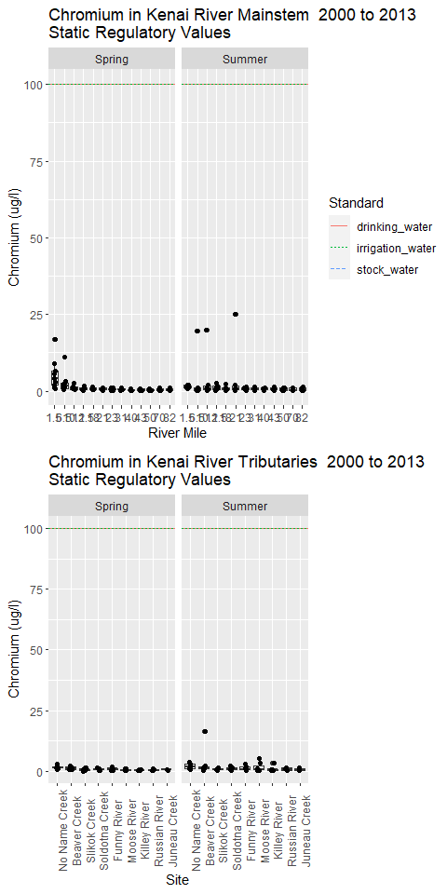

12. Copper
Typically present in surface waters, naturally low concentrations of copper are essential as micronutrients for plants and animals, but elevated levels can be toxic to certain aquatic species (USEPA, 2007). Concentrations of copper can increase in surface waters due to discharges from mining, the leather industry, electrical equipment, and fabricated metal products (USEPA, 2007). Copper is present in the brake pads of vehicles and can enter surface waters in storm water runoff (USEPA, 2015). The standard for copper set by the ADEC, ranges from 1.75 μg/L to 29.28 μg/L, depending on hardness, for chronic exposure to aquatic life in freshwater (see Appendix X) (ADEC 2008).
The highest concentration of copper in the mainstem was reported at _____ μg/L at [site] in [season/year], and the lowest levels were below the MDL of ____ μg/L. In the summer, ____ exceedances occurred at [sites], and copper concentrations exceeded the criteria during individual sampling dates at [sites]. Higher levels occurred ____, while the lowest concentrations were detected at ____. [Were exceedances were recorded for the mainstem during the sampling events in spring/summer?]. Copper concentrations in the tributaries ranged from ___ μg/L in the [site/year] to below the MDL of ___ μg/L that occurred in many locations during this project. Exceedances in the spring occurred at….. Exceedances in the summer occurred at ….
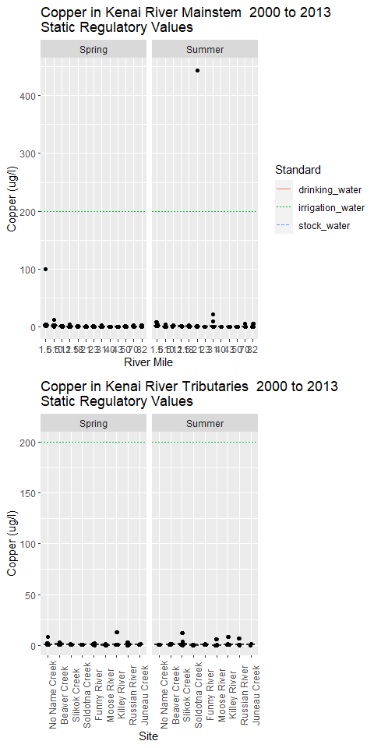

13. Benzene
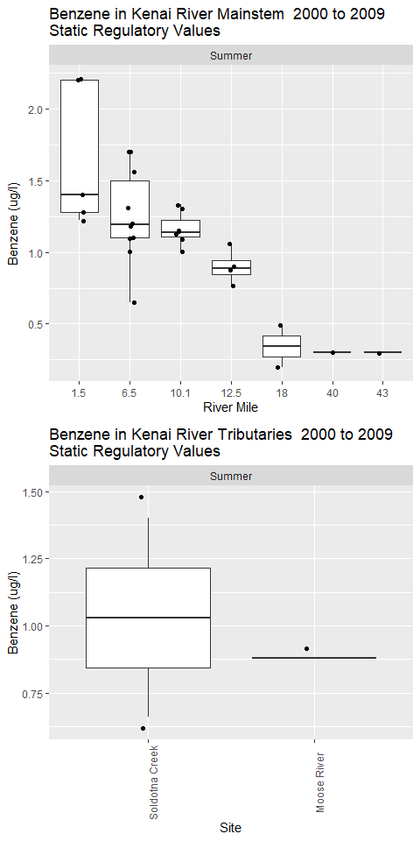

14. Calcium
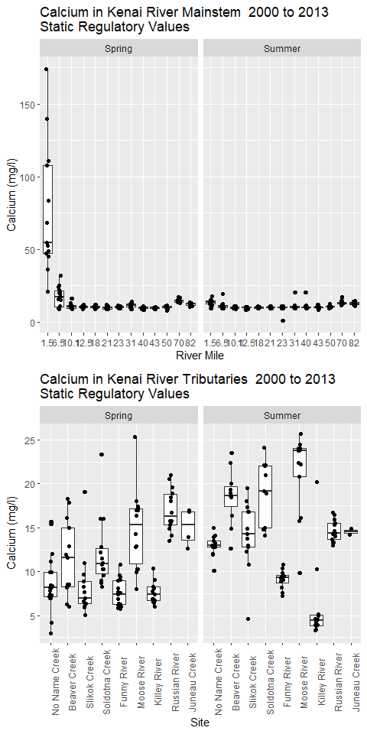

15. Summary
~2 page overall summary here.

References
ADEC. 2020. “18 AAC 70 Water Quality Standards.” https://dec.alaska.gov/media/1046/18-aac-70.pdf.
Apsens, S, and J Petitt. 2022. “Kenai River, Alaska Field Report 2021.”
Dorava, Joseph M, and Alexander M Milner. 2000. “Role of Lake Regulation on Glacier-Fed Rivers in Enhancing Salmon Productivity: The Cook Inlet Watershed, South-Central Alaska, USA.” Hydrol. Process. 14 (16-17): 3149–59. https://doi.org/10.1002/1099-1085(200011/12)14:16/17<3149::aid-hyp139>3.0.co;2-y.
EPA. 2011. “Nonpoint Source Program Success Story, Alaska: Upgrading Boat Motors Reduces Hydrocarbon Pollution.” https://19january2017snapshot.epa.gov/sites/production/files/2015-10/documents/ak_kenai.pdf.
Glass, RL. 1999. “Water-Quality Assessment of the Cook Inlet Basin, Alaska Summary of Data Through 1997.” https://doi.org/10.3133/wri994116.
Guerron Orejuela, Edgar. 2016. “Water Quality Assessment of the Kenai River Watershed from July 2000 to July 2014.” https://dec.alaska.gov/media/16756/kenai-river-baseline-monitoring-report-final-zncuappendix.pdf.
Kenai Watershed Forum. 2012. “Quality Assurance Project Plan, Kenai Watershed Forum, Kenai River Watershed Monitoring Program.”
———. 2019. “Quality Assurance Project Plan, Kenai Watershed Forum, Kenai River Watershed Monitoring Program, V2.0.”
———. 2023. “Kenai River Water Quality Monitoring Quality Assurance Project Plan, Multi-Agency Baseline (QAPP) V3.0.” Soldotna, AK. https://www.kenaiwatershed.org/wp-content/uploads/2023/05/KenaiWatershedForum_QAPP_v3_2023.pdf.
McCard, Jennifer J. 2007. “Water Quality Assessment of the Kenai River Watershed from July 2000 to July 2006.”
Reeves, Mari Kathryn, Margaret Perdue, Lee Ann Munk, and Birgit Hagedorn. 2018. “Predicting Risk of Trace Element Pollution from Municipal Roads Using Site-Specific Soil Samples and Remotely Sensed Data.” Sci. Total Environ. 630 (July): 578–86. https://doi.org/10.1016/j.scitotenv.2018.02.171.
Schoen, Erik R, Mark S Wipfli, E Jamie Trammell, Daniel J Rinella, Angelica L Floyd, Jess Grunblatt, Molly D McCarthy, et al. 2017. “Future of Pacific Salmon in the Face of Environmental Change: Lessons from One of the World’s Remaining Productive Salmon Regions.” Fisheries 42 (10): 538–53. https://doi.org/10.1080/03632415.2017.1374251.

Appendix A — Appendix: Data Review and Upload

A.1 Introduction
Prior to publishing analysis and interpretation of water quality data, we will ensure that all data that meets QA/QC standards outlined in the current project Quality Assurance Project Plan (QAPP) and is accessible in the appropriate repository.
Water quality data from this project is ultimately destined for the Environmental Protection Agency’s Water Quality Exchange (EPA WQX).
The Quality Assurance Project Plan (QAPP) for this project describes data management details and responsible parties for each step of the data pipeline from observation to repository. The 2021 data preparation and review process is published here as an appendix as an example of the process applied annually to each year’s data.

A.1.1 Year 2021 Water Quality Data
In this appendix we will collate 2021 laboratory data from several sources into a single spreadsheet document with a consistent format. The desired end format is a spreadsheet template provided by the EPA Water Quality Exchange. These template files are available to download from the EPA at https://www.epa.gov/waterdata/water-quality-exchange-web-template-files.
Once the data is collated, it will be evaluated according to a Quality Assurance Checklist (template example provided by the Alaska Department of Environmental Conservation Soldotna office). Field observations that do not meet the quality assurance standards described in the evaluation checklist will be flagged before being uploaded to the EPA WQX.
Data that has been uploaded to the EPA WQX is evaluated biannually by the Alaska Department of Environmental Conservation (ADEC) in their Integrated Water Quality Monitoring and Assessment Report. The integrated report evaluates available water quality data from the previous five years against Alaska water quality standards and regulations (ADEC 2020).

A.1.1.1 2021 Water Quality Data AQWMS Formatting
The code scripts in this document assemble water quality data from the three analytical laboratories that partnered with Kenai Watershed Forum for this project in 2021:
- SGS Laboratories (Anchorage, AK)
- Soldotna Wastewater Treatment Plant (Soldotna, AK)
- Taurianen Engineering and Testing (Soldotna, AK)

A.1.1.1.1 2021 Metals/Nutrients Lab Results (SGS Labs)
*Note: the chain of custody documents for SGS Laboratories are integrated into the above downloadable PDF files.

A.1.1.1.2 2021 Fecal Coliform Lab Results (Soldotna Wastewater Treatment Plant (SWWTP)/Taurianen Engineering)

A.1.1.1.3 2021 Total Suspended Solids Lab Results (Soldotna Wastewater Treatment Plant (SWWTP))

A.1.2 2021 Provisional Results, Prior to QA/QC Review
Results last updated 2023-11-20
The above data sources have been collated in to a single .csv file (available for download) into a format compatible with the EPA Water Quality Exchange. These data have not yet been evaluated against QA/QC standards following guidance in the current project Quality Assurance Project Plan.

A.1.3 2021 Data QA/QC Evaluation
Prior to upload to the EPA WQX, all water quality data must be checked against a series of standard questions in order to evaluate how quality assurance / quality check (QA/QC) requirements are met. The draft Data Evaluation Checklist Template (available for download below) outlines these questions:

A.1.3.1 Pre-Database

A.1.3.1.1 Overall Project Success
Note: the sequence of questions is structured such that data will be gradually flagged at each step based on the criteria described.
1.) Were the appropriate analytical methods used for all parameters?
Yes. Analytical methods from the approved 2020 QAPP were employed.

2.) Were there any deviations from the sampling plan?
All sites were visited as planned on 5/11/2021 and 7/27/2021. Most intrinsic water quality parameters measured with instruments (pH, dissolved oxygen, conductivity, turbidity) were not measured.

3.) Were field duplicates, blanks, and/or other QC samples collected as planned?

To see a table comparing planned vs actual results for 2021, download and view the csv file linked above.
From the above table we can see that there are deviations between planned results and actual results available. These reasons for the deviations are known and are attributable to two causes:
Cause 1: The Spring 2021 Chain of Custody (COC) from KWF to SGS was completed erroneously. The COC specified for 200.8 analyses (dissolved metals) to be complete for all sites (when they should have stopped upstream of Morgan’s Landing RM31), and it also specified for 200.7 analyses to stop upstream of Morgan’s Landing (when they should have been performed for all sites in the project).
As a result, for Spring 2021 total metals data will be unavailable for sites upstream of the Morgan’s Landing RM31 site.
Cause 2: For Summer 2021, the SGS laboratory performed the 200.8 analyses (dissolved metals) for all 27 analytes available for the method; instead of just the smaller subset of analytes as requested. (E.g., KWF received extra data for free. In this case., there are no consequences of deviating from the planned analyses).

4.) Do the laboratory reports provide results for all sites and parameters?
The laboratory reports provide results for all sites, and for all parameters, with the exceptions outlined above in question #3.

5.) Is a copy of the Chain of Custody included with the laboratory reports?
We worked with three separate laboratories in 2021:
- SGS Laboratories, Anchorage, AK
  - Chain of Custody documents are included within the PDF laboratory reports linked above earlier in this appendix.
- Soldotna Wastewater Treatment Plant, Soldotna, AK
  - Chain of Custody documents are on file with Kenai Watershed Forum for fecal coliform and total suspended solids for 5/11/2021, and for total suspended solids on 7/27/2021.
- Tauriainen Engineering & Testing, Soldotna, AK
  - An individual document for each sample reports the time and date of delivery and analysis for each sample. These documents are included with the PDF laboratory reports linked above earlier in this appendix.

6.) Do the laboratory reports match the Chain of Custody and requested methods throughout?
The laboratory reports match the Chain of Custody and requested methods, with the one exception discussed in question #3. For summer 2021, the SGS laboratory performed the 200.8 analyses for all 27 analytes available for the method; instead of just the smaller subset of analytes as requested. (E.g., KWF received extra data for free. In this case., there are no consequences of deviating from the planned analyses).

7.) Are the number of samples on the laboratory reports the same as on the Chain of Custody?
The quantity of sample bottles sent to the laboratories matches the number of analyzed samples for samples collected and delivered on 5/11/2021 and 7/27/2021.

8.) Was all supporting info provided in the laboratory report, such as reporting limits for all analyses and definitions?
We worked with three separate laboratories in 2021:
- SGS Laboratories, Anchorage, AK
  - SGS provided data as PDFs which included reporting limits, as well as in the form of an Electronic Data Deliverable where this information is also included in column format.
- Soldotna Wastewater Treatment Plant (SWWTP), Soldotna, AK
  - SWWTP provided data in the form of .xls files. Reporting limits are described in this project’s current Quality Assurance Action Plan.
- Tauriainen Engineering & Testing, Soldotna, AK
  - Tauriainen provided data in the form of PDF documents. Reporting limits are described in this project’s current Quality Assurance Action Plan.

9.) Are site names, dates, and times correct and as expected?
- Yes, after post-season correction documented in this report. Notes: In 2021 Kenai Watershed Forum used pre-printed waterproof labels on all sample bottles, reducing opportunity for field and lab transcription errors. Remaining site name transcription errors from laboratories were corrected in post-season data review.

10.) Were there any issues with instrument calibration?
- Instruments to measure intrinsic water quality parameters (sondes; to measure pH, dissolved oxygen, conductivity, turbidity) were not employed in 2021.
- Teams did use hand-held probes to record water temperature on-site. Prior to field use, the hand-held probes were verified as measuring within the accuracy level defined in the QAPP using an ice bath in the Kenai Watershed Forum laboratory.

11.) Did the instruments perform as expected?
- The hand-held water temperature probes performed as expected in 2021.

12.) Was instrument calibration performed according to the QAPP and instrument recommendations?
- Water temperature is a parameter that is “verified” rather than calibrated. The hand-held water temperature probes were verified as measuring within the accuracy level defined in the QAPP using an ice bath in the laboratory, according to instrument recommendations.

13.) Was instrument verification during the field season performed according to the QAPP and instrument recommendations?
- The hand-held water temperature probes were verified as measuring within the accuracy level define in the QAPP using an ice bath in the laboratory, according to instrument recommendations.

14.) Were instrument calibration verification logs or records kept?
- Yes. These records are held at Kenai Watershed Forum, 44129 Sterling Hwy, Soldotna, AK.

15.) Do the instrument data files site IDs, time stamps and file names match?
- Instrument files were not employed in 2021. Measurements from hand held probes were recorded on waterproof paper field forms.

16.) Is any insitu field data rejected and why?
- No insitu data is rejected from 5/11/2021 or 7/27/2021.

17.) Were preservation, hold time and temperature requirements met?
- Yes. Summer and Spring 2021 holding time requirements were met for all samples. See downloadable files below. Laboratory result documents indicated no compromises of preservation and temperature requirements.
Joining with `by = join_by(epa_analysis_id)`

18.) Are dissolved metal quantities less than total metals quantities?
- Dissolved metals results are not consistently less than total metals results, as would be logically anticipated (see post from Flowlink Environmental website for description and rationale):
  - “Dissolved metal concentration is determined by filtering a water sample through 0.45 uM filter. Water that passes through the filter is analyzed for metals and the result is reported as dissolved metal concentration. Total metal concentration is determined by analyzing the unfiltered sample.
  - “Total metal concentration = Dissolved metal concentration + Particulate (insoluble) metal concentration.”
  - In 2021, there are results available for both dissolved and total metals for three elements: Ca, Fe, and Mg; for sites at and downstream of RM 31.
  - Dissolved metals results are available for 7/27/2021 (summer) only, and not for 5/11/2021 (spring); see question #3 in this sequence.
- Results:
  - Calcium: all available observations show dissolved metals > total metals
  - Iron: all available observations show dissolved metals < total metals
  - Magnesium: nearly all available observations show dissolved metals < total metals, with the exception of three sites, all near the Kenai River mouth

As of Fall 2023 it is unclear why the values measured for total metals is greater than dissolved metals for the cases described above.
See discussion XX in “Summary” section of this report for plans in future years to address the issue of dissolved metals values being greater than total metals values in some cases.

19.) Are the duplicate sample(s) RPD (Relative Percent Difference) within range described in QAPP?
In 2021, field duplicate samples were collected at two sites on both 5/11/2021 and 7/27/2021:
- No Name Creek (Tributary, RM0)
- Funny River (Tributary, RM30)
Following the example in the Alaska Department of Environmental Conservation 2021 Kenai River Metals Field Report (Apsens and Petitt 2022): “… a set of paired samples was evaluated for RPD only if:
- a.) one or both of the samples were above the Limit of Quantitation (LOQ); AND if
- b.) one or both of the samples were at least two times the LOQ.”
A csv file of Relative Percent Difference values organized by site, date, and parameter may be downloaded below:

From the above downloadable table, we can see that a limited subset of paired values from field duplicates are eligible to be used for RPD calculations for 2021. Pairs of measurements must meet LOQ criteria described above (“a” and “b”) in order to be used. For 2021 data, of 69 paired field duplicate observations, 24 of them meet these criteria and thus may be used for RPD calculations.
RPD values range from 0 % to 165.22 %.
In the 2020 Quality Assurance Action Plan, Relative percent Difference values for most parameters are set at 20%, with the exception of “Phosphorus, total” and “Nitrates (NO2+NO3)” at 25%, and “Suspended solids, total” at 5%.
Using the available RPD values against the above criteria, four paired observations exceed project precision goals in 2021. Three of these four observations are for fecal coliform, and one is for total phosphorus.
Most other parameters have at least one available RPD value that is within project precision goals defined in the QAPP. The parameters that do not have at least one RPD calculation available, due to the LOQ constraints described above, are the following:
- Arsenic
- Cadmium
- Chromium
- Copper
- Lead
- Zinc
Other notes
In 2021 the full suite of dissolved metals was run for method 200.8 on samples from 7/27/2021. However we intend to only submit data for parameters that had a pre-defined QA plan as outlined in the QAPP, which is the case for the following dissolved six metals: Mg, As, Cd, Cr, Cu, Pb, and Zn.
Summary of Discussion on RPD (Relative percent Difference) Values for 2021
We attempted to calculate RPD values for all parameters collected in 2021 at two field sites on two dates. For each pair of duplicate observations, one of the following descriptions apply:
- It was possible to calculate RPD values because:
  - a.) one or both of the samples were above the LOQ; AND one or both of the samples were at least two times the LOQ
  - Project data for this parameter will be submitted to EPA WQX if RPD values meet project goals outlined in the QAPP
- It was not possible to calculate RPD values because:
  - a.) one or both of the samples were not above the LOQ; OR one or both of the samples were not at least two times the LOQ
  - Project data for this parameter will be submitted to EPA WQX if both paired values are non-detect
Best practices for interpreting and applying RPD data in order to flag/not flag the overall dataset are currently being finalized. KWF communicated with the Alaska Department of Environmental Conservation on August 22, 2023 via an inquiry on this topic. The memo includes a visual flow chart of the logic for when data is flagged, and is available for download below.

Final determinations on flagging / not flagging 2021 data submitted to the EPA WQX
All 2021 field results will be submitted unflagged to the EPA WQX unless discussed below.
- Fecal Coliform
  - Given that 3 out of 4 RPD values for fecal coliform values are >60%, field data values for the 2021 dataset may vary from actual environmental conditions. The 2020 KWF QAPP does not specify an RPD value for fecal coliform, it only specifies control checks for sterility and temperature. We used EPA Method 9222D (drinking water) for fecal coliform analysis methods, which does not specify an RPD value. However EPA general recommendations for pathogens in sewage sludge recommends and RPD of 20% (link).
  - Given the above considerations, KWF will submit 2021 fecal coliform data to the EPA WQX as “flagged”. Fecal coliform data will be evaluated in this report and assessed against state standards, but given the high RPD values among duplicate samples, 2021 data will likely not be considered in the context of potential regulatory exceedences.
  - TO DO: Calculate and visualize RPD values for 2014-2022 and compare, also compare to RPD values in previous comprehensive report.
- Selected Metals (As, Cd, Cr, Cu, Pb, Zn)
  - Because these parameters do not have an associated RPD value from 2021 field data, they will be submitted to EPA WQX as “flagged.”
  - Note: beginning in Summer 2022, KWF initiated a series of changes to the QAPP that will better facilitate QA/QC decisions regarding Total Metals and Dissolved metals results. These changes include inclusion of a dissolved metals field blank, and changing from field filtration to lab filtration as standard practice.
Joining with `by = join_by(activity_start_date, characteristic_name)`

20.) Were there any laboratory discrepancies, errors, data qualifiers, or QC failures (review laboratory duplicates, matrix spikes and blanks)?
Laboratory discrepancies from the SGS lab are described on page 2 of the spring and summer PDF document reports, which are available for download below.

The following discrepancies were identified in the results from SGS laboratories:
Matrix Spike Recoveries
A total of 6 matrix spike or matrix spike duplicate samples are outside of QC criteria. The limit of recovery range for the analyte “Total Nitrate/Nitrite-N” is 90% - 110%. For these matrix spike measurements outside of the QC criteria, recovery levels range from 112% - 118%. These values that exceed threshold may be downloaded as a table below:

No additional laboratory QA/QC anomalies for any other parameters were noted by any laboratories contracted in 2021. Additional details are available upon request at hydrology@kenaiwatershed.org
As of 2023-11-20, “Total Nitrate/Nitrite-N” values will be flagged for the spring 2021 dataset. (Spring only and not summer because no matrix spike recovery exedences were observed from the summer 2021 lab results). The matrix spike recovery exceedances indicate that reported lab values may be 2% - 7% above actual field values. At a later date we will evaluate these results in the context of year 2000 - present data to help evaluate the relevancy of this flag.

21.) Is any laboratory data rejected and why?
No additional 2021 laboratory data currently indicates a need for being flagged or rejected.

22.) During the field season, review raw data files (EDDs [Electronic Data Deliverables], instrument records) as they are received. Document changes and corrections to methods as needed.
In 2021, KWF initiated as standard practice the receipt of machine-readable EDD files from contracted laboratories, in addition to PDF results. The EDD files are being reviewed as part of this QA/QC process, which was initiated in Winter 2022.

23.) Is the dataset complete and did you receive the expected number of results?
From the discussion and results in question #3, deviations are evident between planned and actual results reported. The reasons for the deviations are known and are attributable to the two factors discussed in question #3, and thus not concerning to project integrity.

24.) Was the data collected representative of environmental conditions?.
The data collected in this project is representative of seasonal hydrological conditions on two fieldwork days in 2021. Conditions vary instantaneously thus this dataset serves to provide representative longitudinal snapshots of the watershed across space on the two dates. Flagged data may indicate that results may require additional interpretation or exclusion from analysis.

25.) Does project meet Completeness Measure A criteria?
From the QAPP, Completeness Measure A: “the primary number of samples collected divided by the usable number of samples submitted to ADEC with a goal of 85% completeness.” (Note that as of 2023 results are now submitted directly to EPA rather than DEC).
(Note: metals parameters not specified in the QAPP are excluded from these analyses. In 2021, SGS laboratories provided dissolved metals results for parameters beyond what was originally requested.)
We calculated Completeness Measure A at the following project scales:
- For individual parameters
- For individual sites
- As a project whole

Discussion on “Completeness Measure A” Results
Based on the data flagging decisions discussed in the previous questions, the 2021 dataset did not achieve all Completeness Measure A goals.
When completeness results were summarized by parameter, all dissolved metals had a value of 0% for Completeness Measure A since the decision was made to flag these as a result of an inability to calculate Relative Percent Difference values.
When completeness results were summarised by Site, Completeness Measure A values ranged from 44.4% - 71.4%, depending on the site’s sampling plan.
When completeness results are summarized for the overall 2021 dataset, Completeness Measure A is calculated at 50.1%; indicating that 50.1% of the overall result values were flagged.

26.) Does project meet Completeness Measure B criteria?
From the QAPP, Completeness Measure B: “the planned number of samples divided by the useable samples (submitted to ADEC) with a goal of 60%.”
For these calculations, we will consider “usable” as “unflagged
- For individual parameters (analysis methods)
- For individual sites
- As a project whole
Work still in progress on calculating Completness Measures B as of 2023-11-20

27.) Was the QA officer consulted for any data concerns?
Note: the 2012 and 2019 approved Quality Assurance Action Plan (QAPP) documents list Alaska Dept of Environmental Conservation Staff as the project’s QA officer (Kenai Watershed Forum 2012, 2019), whereas the 2023 approved QAPP lists Kenai Watershed Forum staff as the project QA officer(Kenai Watershed Forum 2023).
Kenai Watershed Forum consulted regularly with staff from the Alaska Department of Environmental Conservation in order to prepare 2021 field data and confirm methods.

28.) Are the correct monitoring locations associated with the project? Are latitide and longitude filled out in a consistent format?
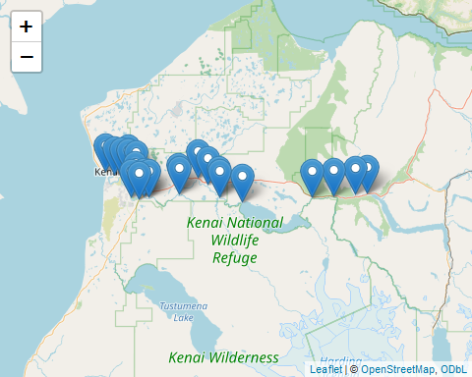
In the above map we can see that coordinates for the 2021 field sites correspond to the locations listed in the Quality Assurance Project Plan, thus they are filled out in a consistent format.

29.) Are the QAPP and other supporting documents attached?
The QAPP will be included and attached in the data submission to the EPA WQX. Find the current approved QAPP posted on Kenai Watershed Forum’s website at https://www.kenaiwatershed.org/news-media/qapp-revisions-completed-2023/.

30.) Is all project metdata correct?
Answer TBD.

31.) Is the organization ID correct?
Kenai Watershed Forum’s Organization ID in the EPA Water Quality Exchange is “EPA_WQX.” This value is manually confirmed during the upload process.

32.) Are the time zones consistent and correct (AKDT in summer)?
All times zones are listed as AKDT.

33.) Are all media types included? Media types appropriate to Characteristic?
“Water” is the only media type considered in this project. All “Characteristics” (parameters) are measured from water samples or in-situ water conditions.

34.) Check Sample Collection, Preparation and Preservation Methods, Thermal Preservative, Equipment ID, Activity Media. Is supporting information included and correct??
[1] "Water Bottle"
“Sample collection method”: all sample values have “Equipment ID” listed as “Water Bottle.”
“Preparation”:this information corresponds to the “result sample fraction” column
“Preservation Methods”: this information corresponds to the “preservative” and “thermal preservative” columns.

35.) Are all expected activity types present and are QC samples correctly identified?
[1] "Field Msr/Obs"
[2] "Quality Control Field Replicate Msr/Obs"
[3] "Quality Control Sample-Trip Blank"

The activity types present are listed above. All three types were planned and anticipated. QC samples are described earlier in Question #3.

36.) Is the Activity media subdivision filled in (if relevant)?
[1] "Surface Water"
All “Activity Media Subdivision” names are listed as “Surface Water.”

37.) For Water activity media, is the relative depth filled in?
Yes, “activity depth height measure” and “activity depth height measure unit” are included as columns.

38.) Is the number of results for each Characteristic correct?
Questions #2 and #3 address this topic in detail. A summary table of the total number of observations for each characteristic is available in the downloadable table below.

39.) Do the range of result values make sense?
Prior to upload to the EPA WQX, the range of results will be evaluated visually and numerically in each characteristic-specific section of the comprehensive report, relative to past results. Likely outliers will be identified and recorded in a dedicated spreadsheet (download below). Each likely outlier will have accompanying notes discussing the choice, and a decisions as to whether a more detailed statistical investigation is warranted.

40.) Are units correct and consistent for each parameter?
Work in progress here as of 2023-11-20

Appendix B — Appendix: Sample Event Timing

B.1 Introduction
Sample event timing for spring and summer events must be chosen with care each year. Sample date occurs on Tuesdays traditionally, and dates must be chosen such that the tide is incoming early in the morning.

B.1.0.0.1 Notes on data sourcing
Data is sourced from the following queries at https://waterqualitydata.us on Feb 24, 2021:
CSV download for sample data: https://www.waterqualitydata.us/portal/#bBox=-151.322501%2C60.274310%2C-149.216144%2C60.738915&mimeType=csv&dataProfile=narrowResult
CSV download for site data: https://www.waterqualitydata.us/portal/#countrycode=US&statecode=US%3A02&countycode=US%3A02%3A122&bBox=-151.322501%2C60.274310%2C-149.216144%2C60.738915&mimeType=csv
Note: these CSV files are excluded from the GitHub repository because they are too large to sync. To reproduce the analysis, download and save these files locally instead. (See the ReadMe file at data/WQX_downloads in the repository).
Using these same queries in the future will download the most current csv files.

B.1.1 Import data
Import data from local csv files
# read in table of known dates from Guerron Orejuela 2016
krbwqm_dates <- read_excel("other/input/sample_dates_tides.xlsx") %>%
rename(activity_start_date = date) %>%
transform(time_max_tide = as.hms(time_max_tide),
time_min_tide = as.hms(time_min_tide)) %>%
select(-data_entry,-link,-sample_date_source,-tide_source) %>%
mutate(julian_day = yday(activity_start_date),
year = year(activity_start_date))

B.2 Dates
# dot plot
krbwqm_dates %>%
ggplot(aes(year,julian_day)) +
geom_point() +
ggtitle("Kenai River Baseline Water Quality Sampling Dates")
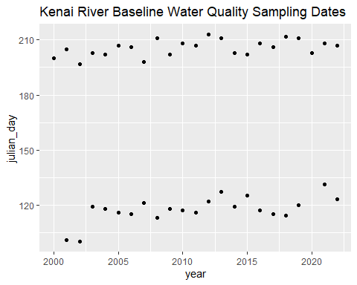
# calculate spring and summer average days
krbwqm_dates %>%
distinct(julian_day,season,year) %>%
group_by(season) %>%
summarise(avg_date = format(as.Date(round(mean(julian_day)), origin = as.Date("2024-01-01")), "%m-%d"),
stdev = round(sd(julian_day)),
n_years = n(),
min_year = min(year),
max_year = max(year))
# A tibble: 2 × 6
season avg_date stdev n_years min_year max_year
<chr> <chr> <dbl> <int> <dbl> <dbl>
1 spring 04-27 7 21 2001 2022
2 summer 07-25 4 23 2000 2022

B.3 Time of Day
# dot plot
krbwqm_dates %>%
ggplot(aes(year,time_max_tide)) +
geom_point() +
facet_grid(.~season) +
ggtitle("Kenai River Baseline Water Quality Sampling Times\nHigh Tides")
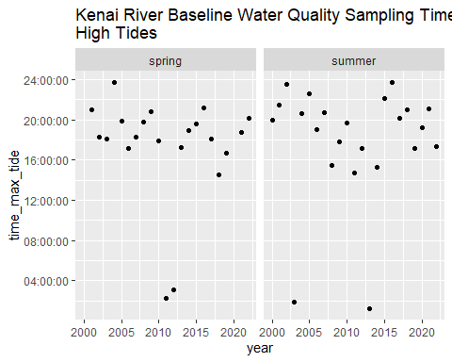
krbwqm_dates %>%
ggplot(aes(year,time_min_tide)) +
geom_point() +
facet_grid(.~season) +
ggtitle("Kenai River Baseline Water Quality Sampling Times\nLow Tides")
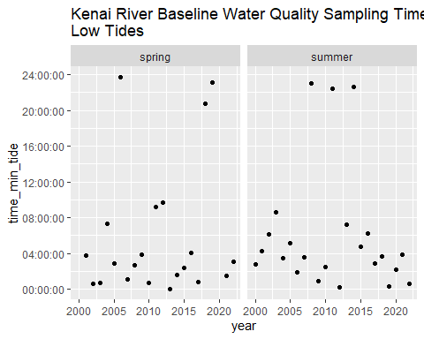
# calculate spring and summer average days
krbwqm_dates %>%
distinct(julian_day,season,year) %>%
group_by(season) %>%
summarise(avg_date = format(as.Date(round(mean(julian_day)), origin = as.Date("2024-01-01")), "%m-%d"),
stdev = round(sd(julian_day)),
n_years = n(),
min_year = min(year),
max_year = max(year))
# A tibble: 2 × 6
season avg_date stdev n_years min_year max_year
<chr> <chr> <dbl> <int> <dbl> <dbl>
1 spring 04-27 7 21 2001 2022
2 summer 07-25 4 23 2000 2022

https://www.kenaiwatershed.org/science-in-action/research-information/water-quality/
https://dec.alaska.gov/water/water-quality/integrated-report/

